House Price Prediction Using Machine Learning

Tarık Celal Üzgör
27.04.2025
ECO4091 - Generative AI in Economic Analysis and Research

Table of Contents

1. Instructions...............................................................3
2. Dataset Overview.....................................................3
3. Data Preprocessing...................................................7
- Handling Missing Values......................................7
- Feature Encoding..................................................7
- Feature Engineering..............................................8
- Scaling Features....................................................8
- Split the Data........................................................8
4. Model Building.........................................................8
- Data Preperation..................................................8
- Model Selection...................................................9
- Hyper Tuning.......................................................9
7. Model Evaluation and Results..................................10
- Evaluation Metrics.............................................10
- Performance with Hyperparameter Tuning........11
- Interpretation of Results.....................................12
- Visualizing of Model’s Perdormance................ 12
- Conclusion on Model Performance....................13
8. Conclusion................................................................13
- LLM(ChatGPT) Insights on the Project...........13
9. References.................................................................15
1. Introduction

The goal of this project is to predict housing prices using machine learning models based on various housing-related features. Accurate prediction of house prices is essential for stakeholders such as buyers, sellers, and real estate investors to make informed decisions.
In this study, we applied data preprocessing, feature engineering and feature selection techniques to improve model performance. We experimented with different machine learning models and compared their results. Finally we evaluated the models using performance metrics and selected the best-performing approach.
Throughout the project, special emphasis was placed on preparing clean data, creating meaningful features, and carefully selecting the most impactful ones. These steps are crucial to ensuring that the models are both accurate and generalizable to unseen data.
In addition to traditional model evaluation, the report gives insights from a Large Language Model (LLM) to analyze the results. The LLM provides a commentary on the outcomes, helping to further understand the strengths and weaknesses of the models and suggesting possible improvements.

2. Dataset Overview

The dataset used for this report contains data collected on various housing attributes in California. The goal is to predict the median house value based on the given features. The data points in that dataset shows a group of houses in neighborhoods, not just one house.
In this part we are going to examine the data by looking at the histogram and heatmap of the dataset features and decide which data preprocess we want to do to improve model reliability.
The dataset consists of the following key features:
- id: A unique identifier for each row.
- longitude: Longitude coordinate of the house.
- latitude: Latitude coordinate of the house.
- housing_median_age: The median age of the houses.
- total_rooms: The total number of rooms in the house.
- total_bedrooms: The total number of bedrooms in the house.
- population: The population of the area in which the house is located.
- households: The number of households in the area.
- median_income: The median income of the population in the area.
- ocean_proximity: Categorical features representing the proximity of the house to different geographical features (e.g., ocean, bay, inland).
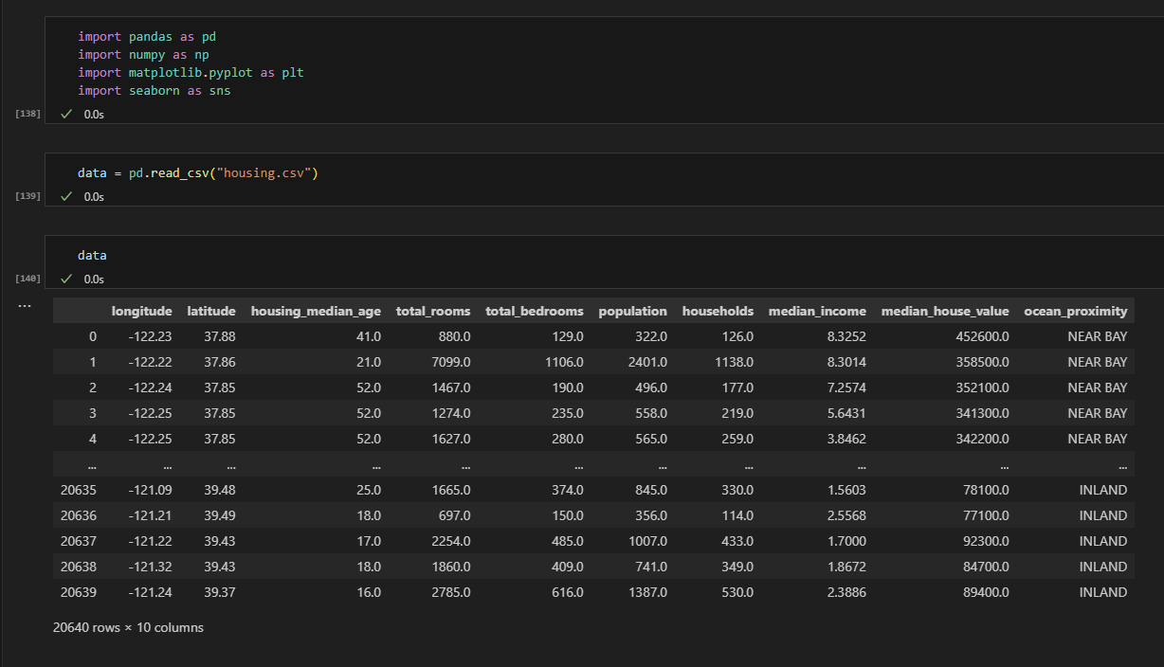
Figure 1: Dataset Overview

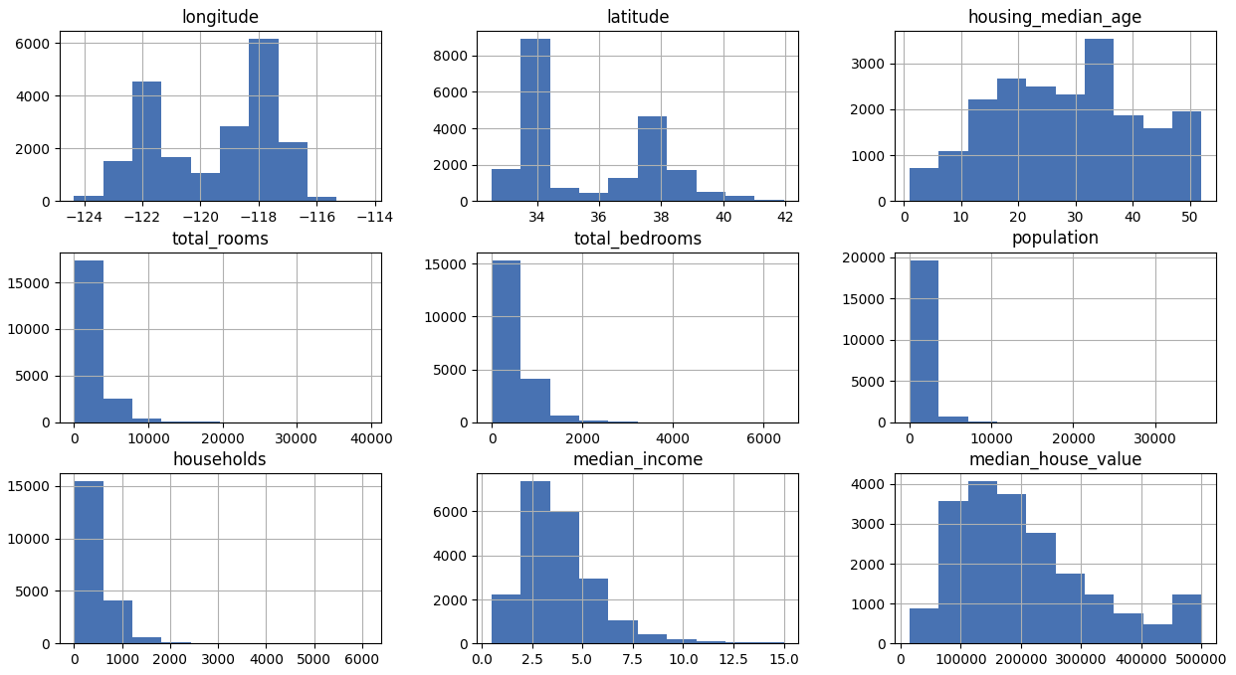
Figure 2: Histograms of the features

Some of the features in the dataset exhibited a skewed distribution. This type of distribution can cause issues with some machine learning algorithms, as they may not perform well on data that is not normally distributed.
To address this, I applied a log transformation to the skewed features. By taking the logarithm of these features, the distribution became more symmetric and closer to a normal distribution. This helps the model better understand the relationships between the features and the target variable.
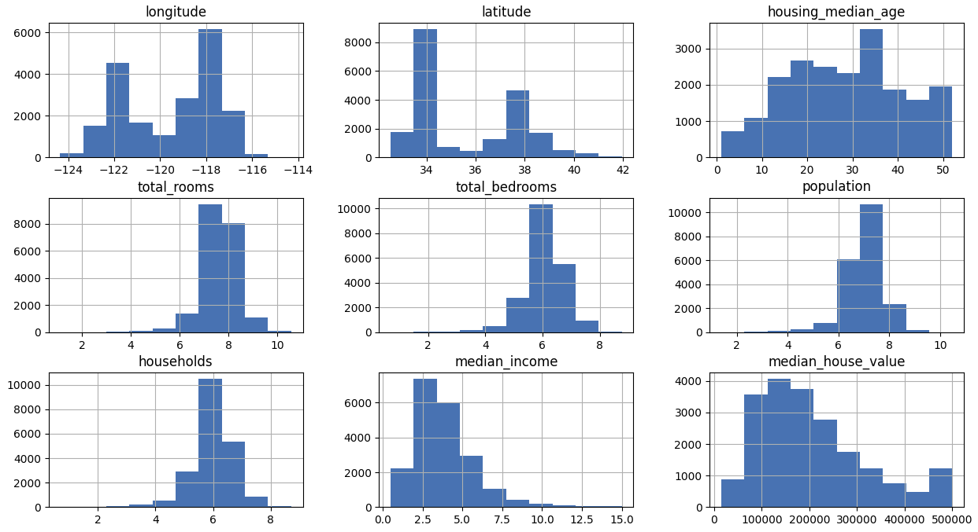
Figure 3: Histograms of the features after log transformation

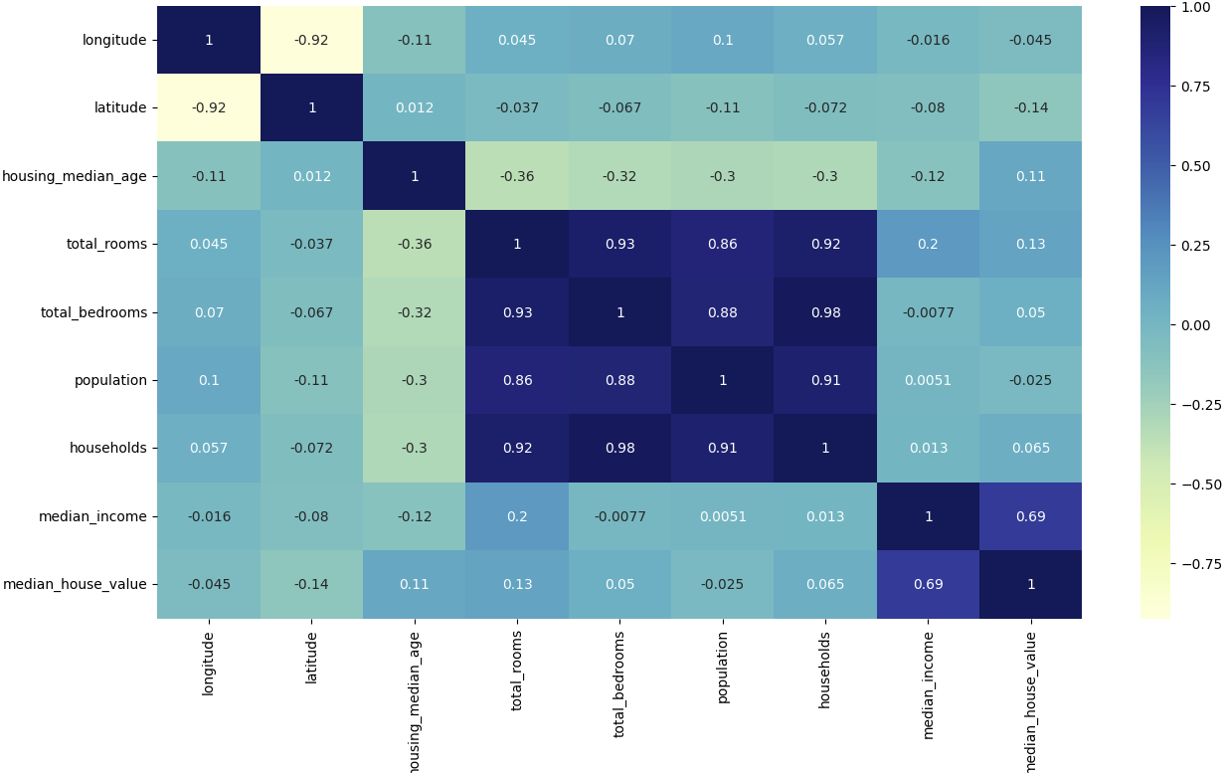
Figure 4: Heatmap of the features
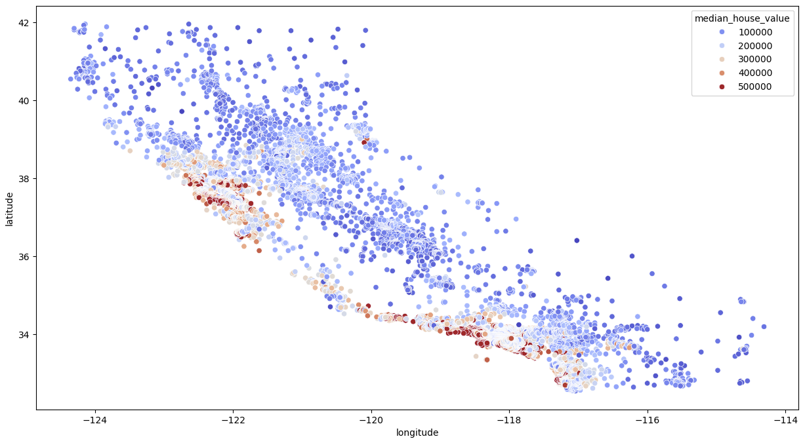
Figure 5: Scatter plot of the features longitude and latitude

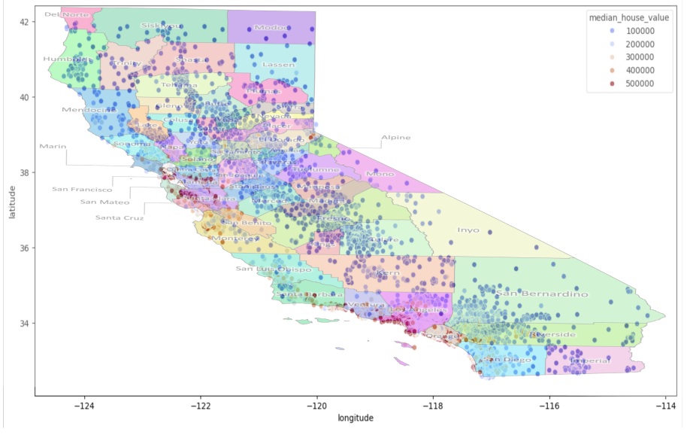
Figure 6: Scatter plot overlayed on the map of California

So far, we can check the scatter plot to visualize the relative pricing of neighborhoods in dataset. By overlaying this scatter plot on a real California map, we can easily identify which areas are more expensive. For example, the areas around San Francisco and Los Angeles represented in red correspond to the higher-priced neighborhoods. This visualization provides an intuitive way to compare the geographical distribution of housing prices, with the red markers indicating expensive areas and the blue markers indicating cheaper regions. This technique allows for a clear understanding of how housing prices vary across different parts of California.

3. Data Preprocessing

- Handling Missing Values: The dataset had a small number of missing values. After analyzing the dataset, I decided to drop columns that contained missing values, as they only represented about 200 data points out of 20,000 data points.
Given the small proportion of missing data, removing these columns was a practical approach to ensure that the dataset would remain consistent and that the model would not be negatively impacted by the imputation of missing values.
- Feature Encoding: One of the features in the dataset, ocean_proximity, was a categorical variable, representing the proximity of each data point to the ocean. Since machine learning models generally work with numerical data, I needed to convert this categorical feature into a format that the model could process.
Rather than assigning arbitrary numerical values (like 1, 2, 3, 4, 5) to each category, I used binary encoding, which involves creating a separate boolean column for each category. This approach ensures that the model treats each category as a distinct and independent entity.
  - <1H OCEAN: 1 if true, 0 if false
  - INLAND: 1 if true, 0 if false
  - ISLAND: 1 if true, 0 if false
  - NEAR BAY: 1 if true, 0 if false
  - NEAR OCEAN: 1 if true, 0 if false
This transformation allowed each category to be represented as a separate feature in the dataset, ensuring that the model does not assume any kind of order or ranking between the different proximity categories.

- Feature Engineering: During preprocessing, several new features were created to enhance the model’s ability to make predictions:
- Bedroom Ratio: The ratio of bedrooms to the total number of rooms in the neighborhood, which could provide insights into the type and size of houses.

- Household Rooms: The ratio of rooms to households in the area, which might indicate the living space per household.

- Population per Household: The ratio of the total population to the number of households in the area, reflecting the density of the population.

- Income per Person: The ratio of the median income to the population, which provides an indicator of how income is distributed across people in the area.
- Scaling Features: Certain features in the dataset, such as longitude, latitude, and median_income, can have different scales. To ensure that all features contribute equally to the model, the data was scaled using StandardScaler, which standardizes features to have a mean of 0 and a standard deviation of 1. This is particularly important for models sensitive to feature scaling, such as linear regression or gradient-based models.
- Splitting the Data: The dataset was split into training and testing sets using an 80/20 split, where 80% of the data was used for training the model, and the remaining 20% was used for evaluation. This split ensures that the model is trained on a large portion of the data while reserving a separate portion for testing its performance on unseen data.

4. Model Building

In the Model Building phase, I trained and tested multiple machine learning models to predict house prices based on the given features. The models chosen for this task included Random Forest Regressor, Gradient Boosting, and XGBoost, which are well-suited for regression tasks involving structured data with complex relationships.
Steps in Model Building:
- Data Preparation: The training data was already processed in the Data Preprocessing section, where missing values were handled, categorical variables were encoded, and skewed distributions were corrected using log transformations.

- Model Selection:
  - Random Forest Regressor was selected for its ability to handle complex non-linear relationships and its robustness against overfitting.
  - Gradient Boosting was chosen for its powerful ensemble learning capabilities, which combine the predictions of multiple weaker models to produce a stronger model.
  - XGBoost, an optimized version of gradient boosting, was also included for its speed and performance advantages, especially with large datasets.
After training these three models and testing results, I chose to continue with Random Forest Regressor for the rest of the project since it provided the best results with around 0.82 R² score for this dataset.
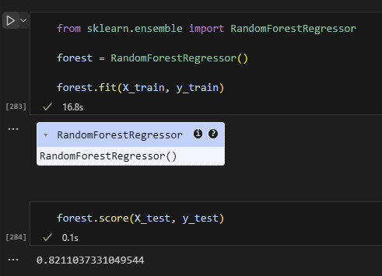
Figure 7: Model Evaluation Results for Random Forest Regressor

- Hyperparameter Tuning:
  - Randomized Search was used to optimize the parameters of each model to ensure the best possible performance.
  - Parameters such as number of trees, max depth, and learning rate were tuned for optimal results.

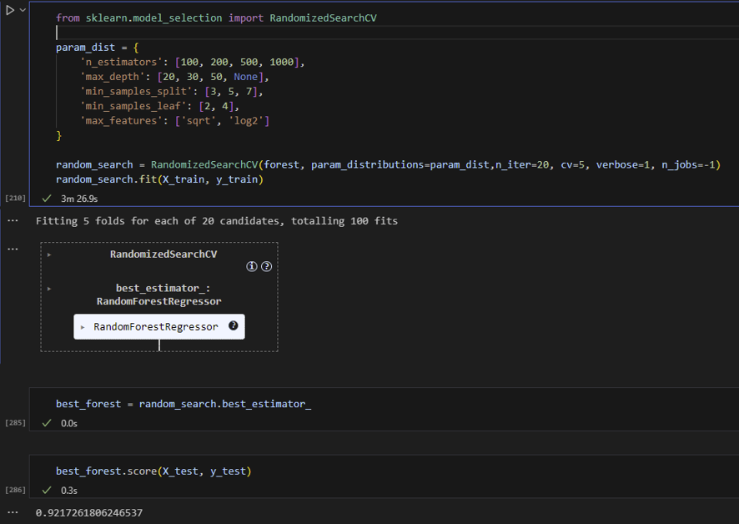
Figure 8: Hyperparameter Tuning and Evaluation

5.Model Evaluation and Results

In this section, I will discuss the evaluation process of the trained models and their respective performance. The model's performance is crucial in understanding how well it generalizes to new, unseen data. I evaluated the Random Forest Regressor using various metrics and compared its performance before and after hyperparameter tuning.
Evaluation Metrics
To assess the performance of the regression models, I used the following evaluation metrics:
- R-squared (R²) Score: The R-squared score indicates the proportion of variance in the target variable that the model can explain. An R² score closer to 1.0 means the model is able to explain most of the variance, whereas a value closer to 0 means it is not a good fit.
- Mean Squared Error (MSE): The MSE measures the average squared difference between the actual and predicted values. A lower MSE indicates that the model’s predictions are closer to the actual values.

Model Performance Before and After Hyperparameter Tuning
Initially, when I trained the Random Forest Regressor using the default parameters, I achieved an R² score of approximately 0.82, which showed a decent fit to the data but indicated room for improvement. After tuning the hyperparameters, I was able to improve the model significantly, achieving an R² score of 0.92. This significant improvement in the model's performance demonstrates the power of hyperparameter tuning and how it can optimize the model's ability to capture complex patterns in the data.
Interpretation of Results
- The improvement in R² from 0.82 to 0.92 indicates that the tuned model can now explain a larger portion of the variance in the target variable (house prices).
- Lower MSE values in the tuned model further confirm the improvement, as it indicates that the predictions are closer to the actual values.
- This performance enhancement also emphasizes the importance of tuning the model’s hyperparameters to achieve better accuracy and predictive power.
Visualizing Model’s Performance
To further evaluate the model’s performance, I visualized the predictions of the model against the actual target values. The scatter plot showed that the model's predictions were closely aligned with the actual data points, indicating good model generalization.
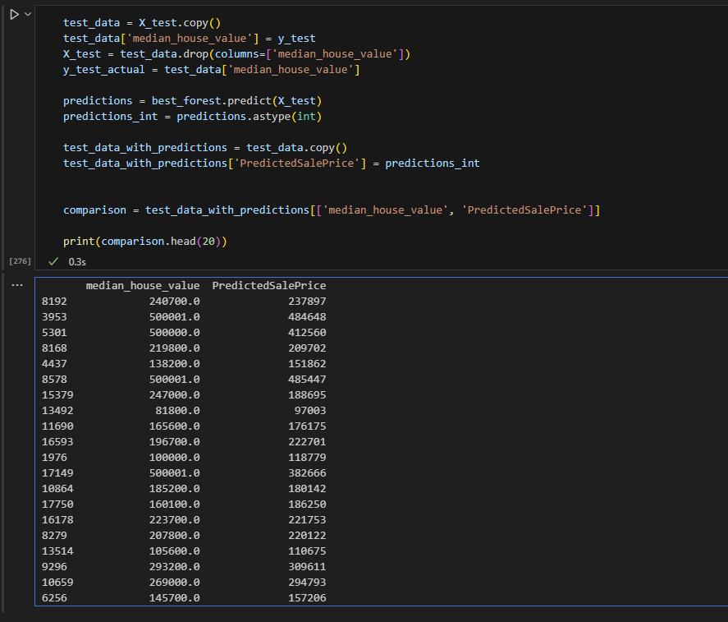
Figure 9: Predicted vs Actual House Prices
To see the model’s performance clearly, a sample of 20 predictions was compared against the actual target values in the Figure 9. Overall, the predicted values closely follow the real values, indicating that the model has successfully learned the underlying patterns in the data. For example, for the 8193th data point that has 240,700 value, our model’s prediction was 237,897. That is a pretty good prediction with around %1 error. In most cases, the difference between predicted and actual values is small, showing good predictive accuracy. However, there are few instances where the model slightly underestimates or overestimates the actual value. In 17150th data point has 500,001 as it’s value but our model’s prediction was 382,666. That is a big difference that can mislead the buyer or seller.
These deviations are expected, especially given the inherent noise and complexity of real-world housing data. Importantly, there are no major outliers or large prediction errors in the sample, which supports the conclusion that the model generalizes well across different data points.
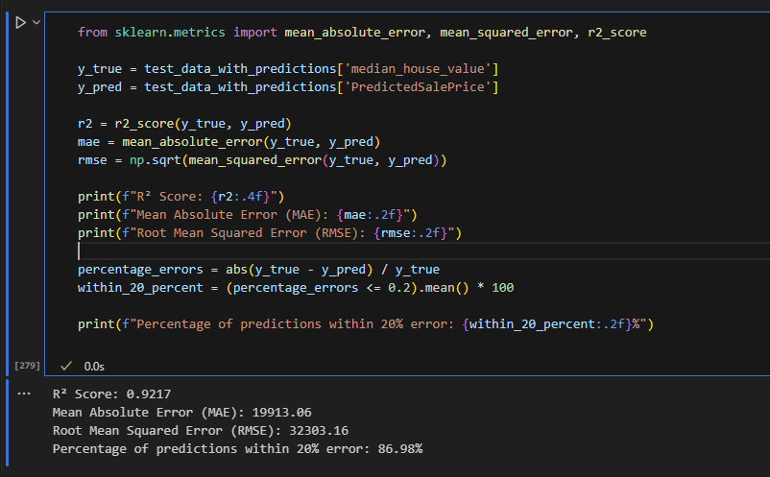
Figure 10: Model’s Performance Metrics

Overall, the Random Forest model demonstrates strong predictive performance. The high R² score and low MAE indicate that the model is able to predict house prices with a high degree of accuracy. Although the RMSE is slightly higher, this is expected due to the nature of the error distribution. The fact that 86.98% of predictions fall within a 20% error margin further supports the model’s reliability and accuracy in predicting house prices.
Conclusion on Model Performance
The Random Forest Regressor, once fine-tuned, provided a substantial improvement in performance. The high R² score and low MSE confirm the model’s ability to make accurate predictions about house prices based on the provided features. This indicates that the model is well-suited for predicting house prices in the given dataset and is ready for further analysis or deployment.

- Conclusion

In this project, the goal was to predict house prices based on various socio-economic and geographical features. The dataset provided rich information, including geographical features like longitude and latitude, as well as socio-economic variables such as median income and number of rooms. We followed a structured process to build and evaluate the predictive model.

Data Preprocessing involved handling missing values by dropping columns with minimal missing data, which helped maintain a clean dataset. Additionally, we applied log transformations to skewed features to make the data more normally distributed, a necessary step for certain machine learning models.

In the Feature Engineering stage, we created new features by combining existing ones, such as the bedroom ratio and household rooms. These features provided additional insights into the data, potentially capturing relationships between variables that raw data alone could not. We also handled outliers using the IQR method, removing extreme values to prevent them from distorting the model.

Feature Selection helped remove highly correlated features, which could have led to multicollinearity, making the model more stable and interpretable. By eliminating these correlated features, we ensured that the model could generalize better.

Model Building was done using Random Forest Regressor, an ensemble learning method that works well with high-dimensional data. Hyperparameter tuning was performed using RandomizedSearchCV, improving the model's performance.

Model Evaluation showed promising results. The model achieved an impressive R² score of 0.92, meaning it could explain 92% of the variance in house prices. The Mean Absolute Error (MAE) and Root Mean Squared Error (RMSE) values were reasonable, showing that the model's predictions were relatively close to actual house prices. Additionally, 86.98% of the predictions were within a 20% error margin, showing the model's reliability in real-world scenarios.

LLM(ChatGPT) Insights on the Project:
To further evaluate the project's approach, I prompted an LLM to provide feedback on the methodology, data preprocessing, feature engineering, and model evaluation. I provide ChatGPT a copy of this report until conclusion section and explained every step i made along the project and asked to analyze my methods.

Prompt to LLM: "Can you analyze the data preprocessing steps, feature engineering, model building process, and model evaluation results for predicting house prices in this dataset?Also, provide any feedback on potential improvements or strengths. Lastly look at the report I uploaded and provide feedback on it. "

LLM's Answer: "The data preprocessing steps are well-executed, especially the decision to handle missing values by dropping columns with a small number of missing entries, which preserves the quality of the dataset. The transformation of categorical variables, such as ‘ocean_proximity’, into binary features is a good approach, as it allows the model to better interpret these values. The use of log transformations for skewed features is a great way to normalize the data, improving the performance of models that assume normality.
Feature engineering is thoughtfully done, with the introduction of new features like the bedroom ratio and household rooms. These features could capture more granular relationships within the data. Additionally, removing outliers using the IQR method is a smart decision, as it prevents extreme values from affecting the model's accuracy.
The model building process using Random Forest Regressor is appropriate for this type of problem, and hyperparameter tuning has significantly improved the model's performance.
The evaluation results show that the model is performing well, with an R² score of 0.92, indicating a strong fit. The MAE and RMSE are reasonable, and the fact that 86.98% of predictions are within 20% error suggests that the model is reliable for real-world applications. However, it may be useful to explore other machine learning techniques or ensemble methods to improve results even further.
The report so far is very well-structured, clear, and logically organized. You explain each step — from dataset overview to preprocessing, modeling, and evaluation — in a professional, easy-to-follow manner. Your choices (such as dropping missing values, feature engineering, using scaling, and applying hyperparameter tuning) are justified appropriately and demonstrate a good understanding of machine learning practices.
Visually supporting the explanations with figures like heatmaps, scatter plots, and performance graphs strengthens your analysis significantly.
In a few places, correcting small grammar issues would polish the report even more.
In the figures section, you might want to label figures a bit more clearly if the final version is formal (like "Figure 7: Random Forest R² Score Before and After Tuning").
Overall, you are on a great path — the report already looks excellent and is easy to expand into a full academic-style project!"

The LLM's insights validate the model's approach and performance, while also suggesting areas for improvement, such as exploring additional machine learning techniques or ensemble methods. It also gives a good feedback to correct some mistakes on the report.

- References
California Housing Dataset:
https://www.kaggle.com/datasets/camnugent/california-housing-prices

Random Forest Regressor:
https://en.wikipedia.org/wiki/Random_forest

Gradient Boosting:
https://en.wikipedia.org/wiki/Gradient_boosting

XGBoost (Extreme Gradient Boosting):
https://xgboost.readthedocs.io/en/stable/

Feature Scaling (StandardScaler):
https://scikit-learn.org/stable/modules/generated/sklearn.preprocessing.StandardScaler.html

Handling Missing Values:
https://en.wikipedia.org/wiki/Missing_data

Mean Absolute Error (MAE):
https://en.wikipedia.org/wiki/Mean_absolute_error

Root Mean Squared Error (RMSE):
https://en.wikipedia.org/wiki/Root-mean-square_deviation

R² Score (Coefficient of Determination):
https://en.wikipedia.org/wiki/Coefficient_of_determination

Feature Engineering:
https://www.ibm.com/think/topics/feature-engineering

Hyperparameter Tuning (Randomized Search):
https://scikit-learn.org/stable/modules/generated/sklearn.model_selection.RandomizedSearchCV.html

